- 按Fn+右Shift+ESC进入DFU升级BOOT
Press Fn + Right Shift + ESC to enter DFU and upgrade BOOT.
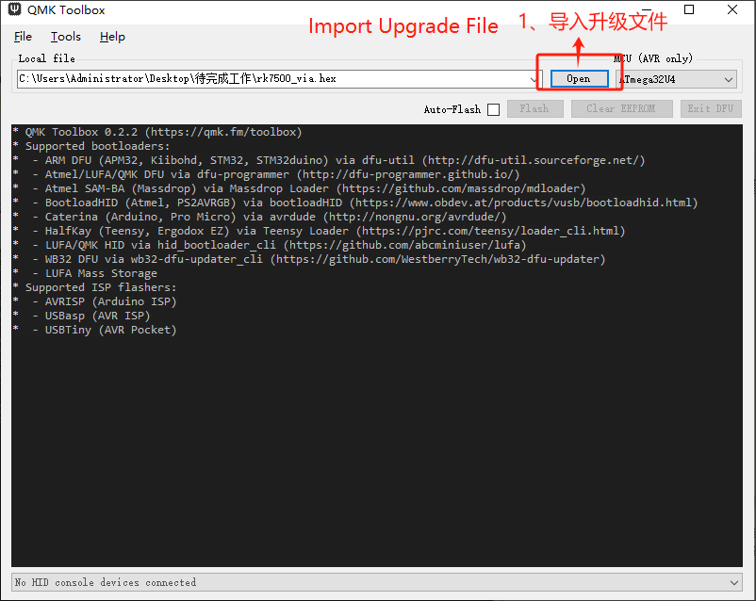

- 点击flash, 进入自动烧录。
Click “Flash” to enter automatic burning process.

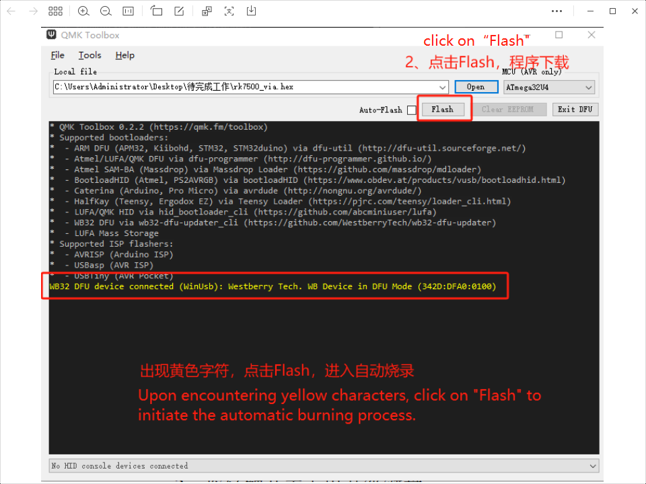

- 烧录完成
Flash Completed.
